Caroline Bakker Hofland

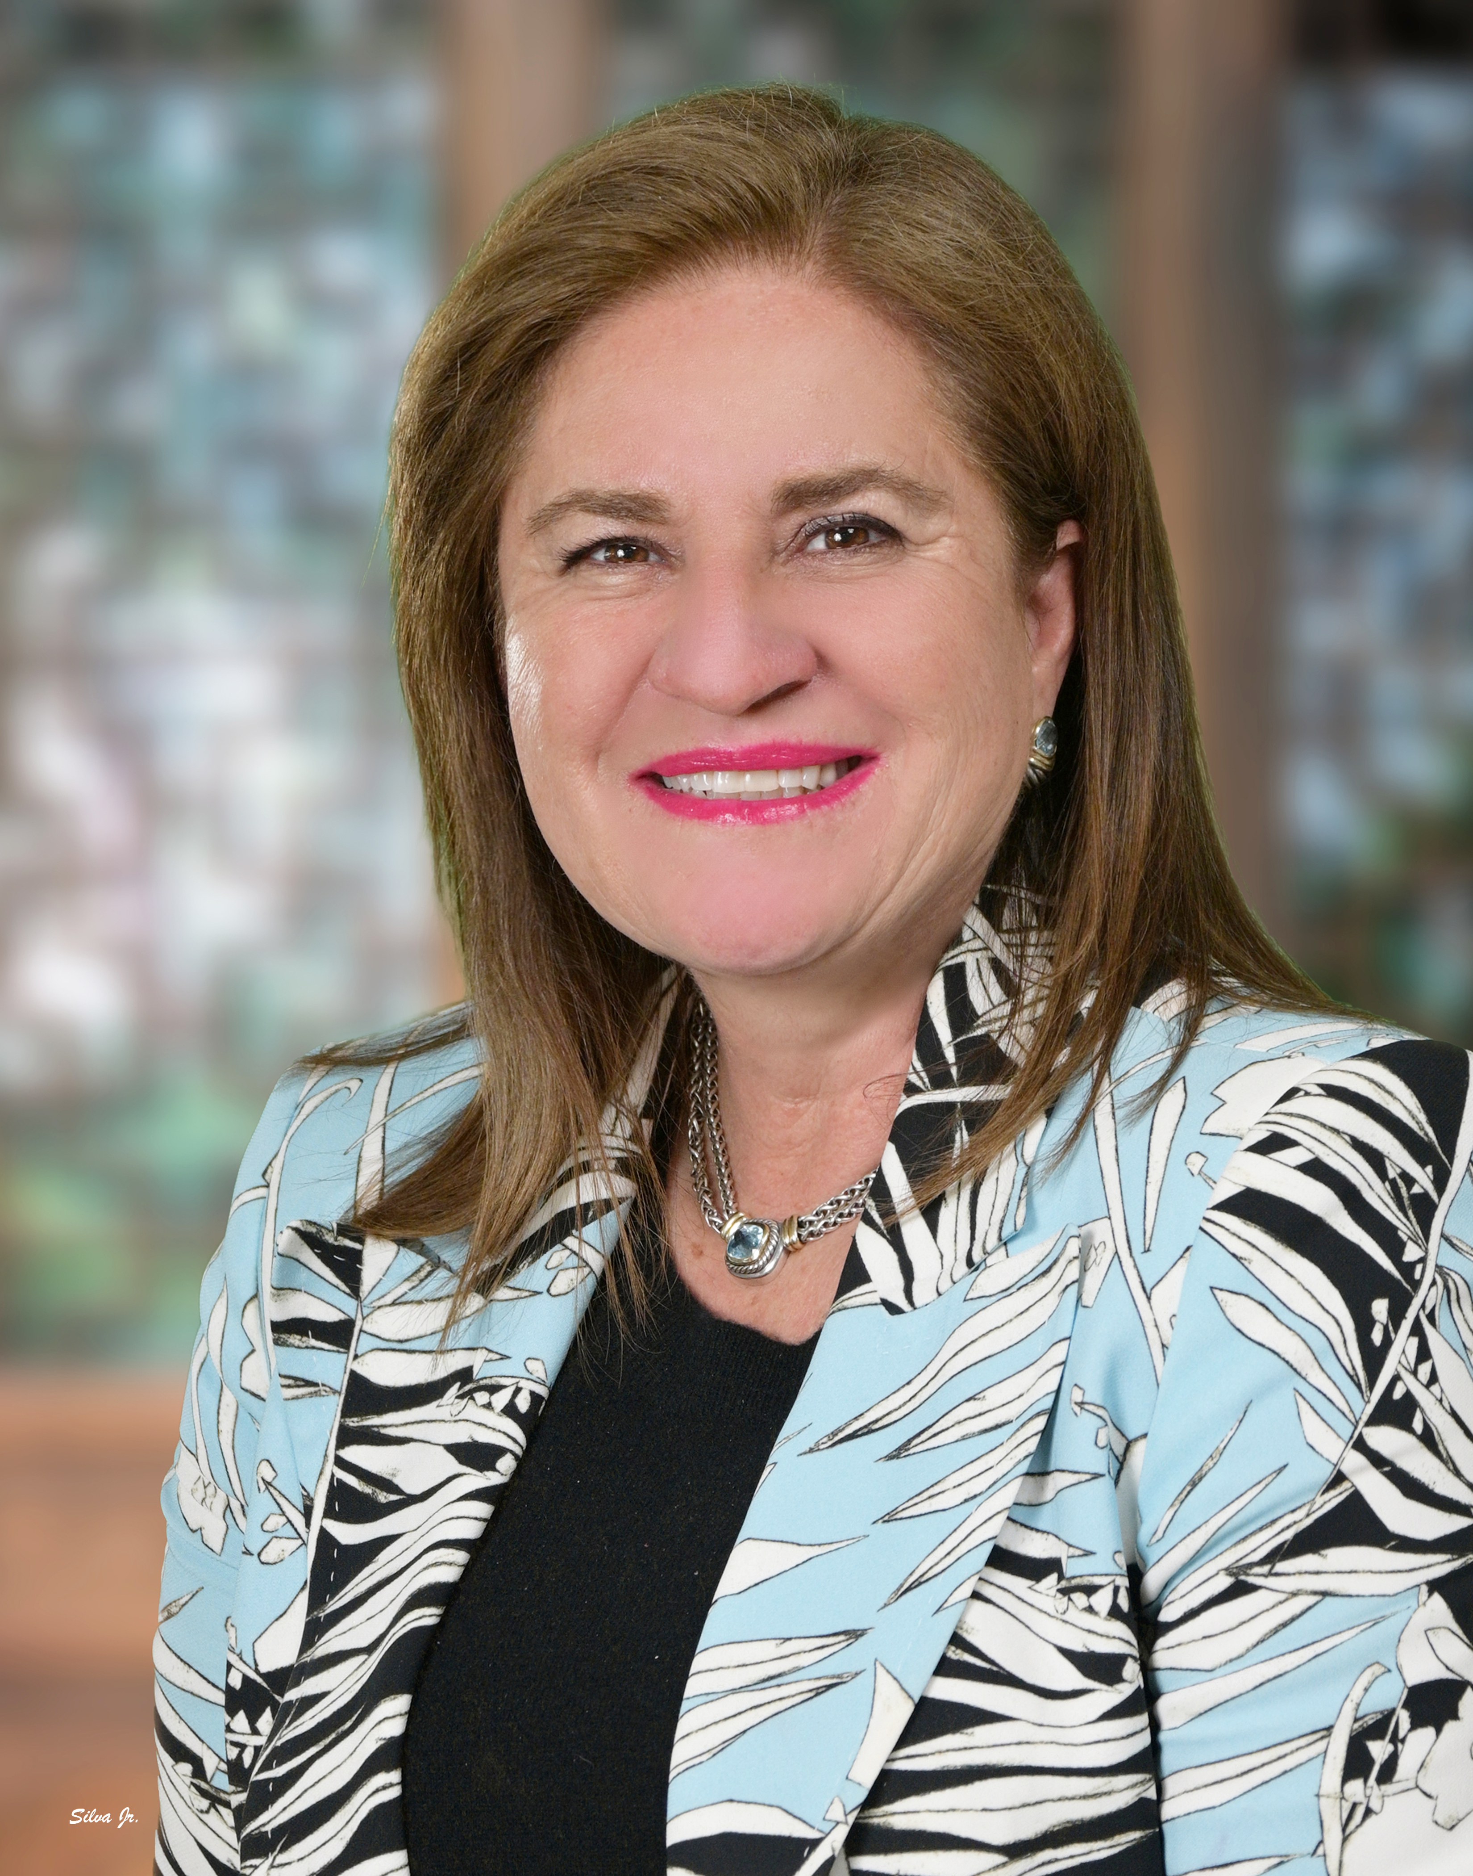

Caroline Bakker Hofland, president and CEO of CBH International, Inc. received her B.S. and M.S. degrees with a
major in Agricultural Economics from the University of Georgia.

Caroline’s first experience in the business world was with the start up of European Plant Design. This
company introduced ornamental hydroculture in the State of Georgia. A few years later she worked
with the Ivan Allen Company as the Business Development Manager where she learned to manage
furniture projects sold to large corporations such as Worldspan.

In 1990 she had the desire to start her own company in Atlanta Georgia, CBH International, Inc., and apply her
degree focusing on International Business selling providing equipment and added value service to the Latin American Poultry.

After thirty-two (32) years in business Caroline operates from her offices in Atlanta Georgia and Quito Ecuador representing world recognized manufactures in the Poultry and Swine industries bringing their leading technology to Central America, Chile, Ecuador, and Peru to better serve her customers. These manufacturers are from Brazil, Germany, The Netherlands, Spain, and The United States

Her goal is to find the best possible solutions to the customers’ projects together with the manufacturers at a competitive price, providing outstanding service before, during, and after the projects are completed. Our goal is to bring Leading Technology to feed humanity.

Caroline participates in many industry shows, the IPPE in Atlanta each year, the LatAm Poultry Show being the most important. She serves in the Atlanta Symphony Orchestra and Red Hare Brewing Company board of directors.
She is a member of The Netherlands Chamber of Commerce, the USDF, USEF, USPREBA, USPREA, GDCT, and Great Dane Club of America.
She has received a certificate of membership from The Honor Society of Agriculture Gamma Sigma Delta. Her company, CBH International, has received numerous awards from suppliers and customers for its outstanding service to the Agribusiness.

Caroline provides customers with a value added service, which requires more than just selling equipment. She explains the following:
“Working in the international market is not only about selling equipment, but it involves constant knowledge of the
Import laws, political atmosphere, currency fluctuations, commodities stability, and animal health issues in each
country CBH is involved in. To be successful one must master these issues and one must work with the Triangle of
Success finding a win win for all parties involved with Integrity, Leadership, Innovation and Commitment and most important loving what one does.”

Caroline has a daughter, Nicole who has graduated successfully in CAES at UGA and now doing her master’s degree at the University of Wageningen in The Netherlands. In her leisure time she enjoys being with family and friends, has many hobbies --riding dressage with her PRE horses, showing her Great Danes, photography, cooking, listening to music especially the Atlanta Symphony Orchestra and traveling.

